Ideation Phase
Define the Problem Statements

Date | 31 January 2025
Team ID | LTVIP2026TMIDS88461
Project Name | DocSpot — Seamless Appointment Booking for Health
Maximum Marks | 2 Marks

Customer Problem Statement Template:
A Customer Problem Statement helps teams deeply understand the challenges faced by their users from the customer’s perspective. It ensures that solutions are built around real needs rather than assumptions.
This template encourages empathy by clearly identifying:
- Who the customer is
- What they are trying to achieve
- What obstacles they face
- Why those obstacles exist
- How those challenges make them feel
By clearly defining these elements, teams can design meaningful solutions that directly address user pain points and create experiences customers truly value.
A well-structured problem statement:
- Aligns the team around real user needs
- Prevents building unnecessary features
- Encourages user-centric thinking
- Guides decision-making throughout the project
- Improves clarity before moving into solution design
Understanding the problem from the customer’s viewpoint allows the team to build solutions that are practical, relevant, and impactful.


Example:
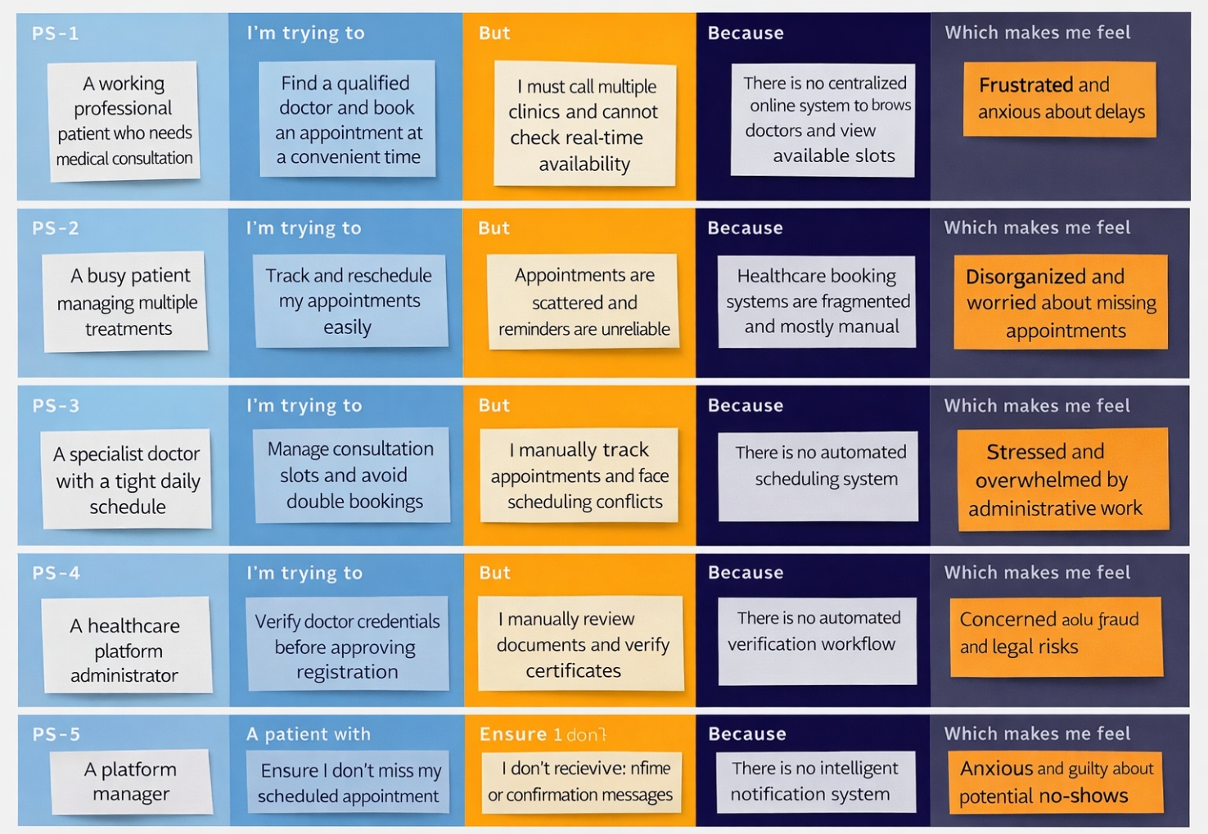
Problem Statement (PS) | I am (Customer) | I’m trying to | But | Because | Which makes me feel
PS-1 | A working professional patient who needs medical consultation | Find a qualified doctor and book an appointment at a convenient time | I must call multiple clinics and cannot check real-time availability | There is no centralized online system to browse doctors and view available slots | Frustrated and anxious about delays
PS-2 | A busy patient managing multiple treatments | Track and reschedule my appointments easily | Appointments are scattered and reminders are unreliable | Healthcare booking systems are fragmented and mostly manual | Disorganized and worried about missing appointments
PS-3 | A specialist doctor with a tight daily schedule | Manage consultation slots and avoid double bookings | I manually track appointments and face scheduling conflicts | There is no automated scheduling system | Stressed and overwhelmed by administrative work
PS-4 | A doctor preparing for consultations | Access patient history before appointments | Patient information is not centralized or easily accessible | Current systems lack integrated patient data management | Unprepared and concerned about consultation quality
PS-5 | A healthcare platform administrator | Verify doctor credentials before approving registration | I manually review documents and verify certificates | There is no automated verification workflow | Concerned about fraud and legal risks
PS-6 | A platform manager | Monitor system performance and user engagement | There is no real-time analytics dashboard | The system lacks integrated reporting and insights | Uncertain and unable to make data-driven decisions
PS-7 | A patient with a busy lifestyle | Ensure I don’t miss my scheduled appointment | I don’t receive timely reminders or confirmation messages | There is no intelligent notification system | Anxious and guilty about potential no-shows
PS-8 | A doctor running a clinic | Reduce patient no-shows and optimize time utilization | Patients don’t confirm or cancel appointments in advance | The system lacks a confirmation and reminder mechanism | Frustrated due to lost revenue and wasted time

